**Assignment-1**

**Dept Table:**

|  |  |  |
| --- | --- | --- |
| **DeptNo** | **Dname** | **Loc** |
| 10 | Accounts | Bangalore |
| 20 | IT | Delhi |
| 30 | Production | Chennai |
| 40 | Sales | Hyd |
| 50 | Admn | London |

**Emp Table:**

|  |  |  |  |  |  |  |
| --- | --- | --- | --- | --- | --- | --- |
| **EmpNo** | **Ename** | **Sal** | **Hire_Date** | **Commission** | **DeptNo** | **Mgr** |
| 1001 | Sachin | 19000 | 1-Jan-1980 | 2100 | 20 | 1003 |
| 1002 | Kapil | 15000 | 1-Jan-1970 | 2300 | 10 | 1003 |
| 1003 | Stefen | 12000 | 1-Jan-1990 | 500 | 20 | 1007 |
| 1004 | Williams | 9000 | 1-Jan-2001 | NULL | 30 | 1007 |
| 1005 | John | 5000 | 1-Jan-2005 | NULL | 30 | 1006 |
| 1006 | Dravid | 19000 | 1-Jan-1985 | 2400 | 10 | 1007 |
| 1007 | Martin | 21000 | 1-Jan-2000 | 1040 | NULL | NULL |

1. Select employee details of dept number 10 or 30
2. Write a query to fetch all the dept details with more than 1 Employee.
3. Write a query to fetch employee details whose name starts with the letter “**S”**
4. Select Emp Details Whose experience is more than 2 years
5. Write a SELECT statement to replace the char “a” with “#” in Employee Name ( Ex: **Sachin** as **S#chin)**

1. Write a query to fetch employee name and his/her manager name.
2. Fetch Dept Name , Total Salry of the Dept
3. Write a query to fetch **ALL** the employee details along with department name, department location, irrespective of employee existance in the department.
4. Write an update statement to increase the employee salary by 10 %
5. Write a statement to delete employees belong to Chennai location.
6. Get Employee Name and gross salary (sal + comission) .
7. Increase the data length of the column Ename of Emp table from 100 to 250 using ALTER statement
8. Write query to get current datetime
9. Write a statement to create STUDENT table, with related 5 columns
10. Write a query to fetch number of employees in who is getting salary more than 10000
11. Write a query to fetch minimum salary, maximum salary and average salary from emp table.
12. Write a query to fetch number of employees in each location
13. Write a query to display emplyee names in descending order

1. Write a statement to create a new table(**EMP_BKP**) from the existing **EMP** table
2. Write a query to fetch first 3 characters from employee name appended with salary.

21) Get the details of the employees whose name starts with **S**

**22) Get the details of the employees who works in Bangalore location**

**23) Write the query to get the employee details whose name started within any letter between A and K**

24) Write a query in SQL to display the employees whose manager name is **Stefen**

**25) Write a query in SQL to list the name of the managers who is having maximum number of employees working under him**

**ANSWERS**

1. Select employee details of dept number 10 or 30

select *from Employee

where dept_no=10 or dept_no=30;

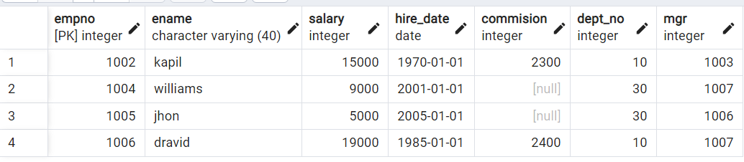

1. Write a query to fetch all the dept details with more than 1 Employee.

select Employee.Empno,employee.Ename,Department.Dept_no,Department.Dname,Department.loc

from Employee

inner join Department on Employee.dept_no=Department.dept_no;

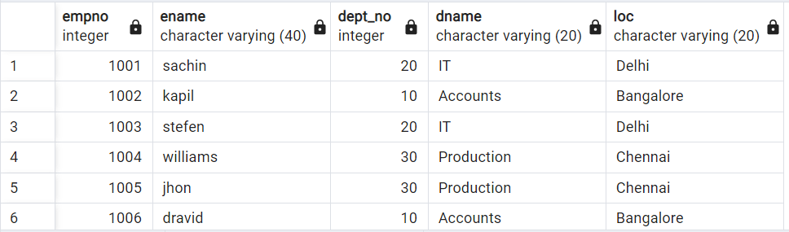

1. Write a query to fetch employee details whose name starts with the letter “**S”**

select *from Employee

where Ename like 's%';

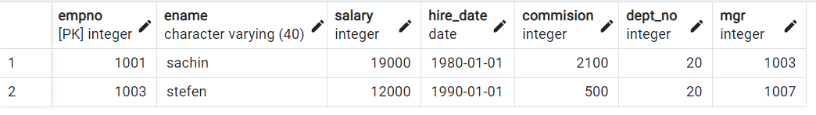

1. Select Emp Details Whose experience is more than 2 years

select *from employee

where extract(year from age(CURRENT_DATE,hire_date))>2;

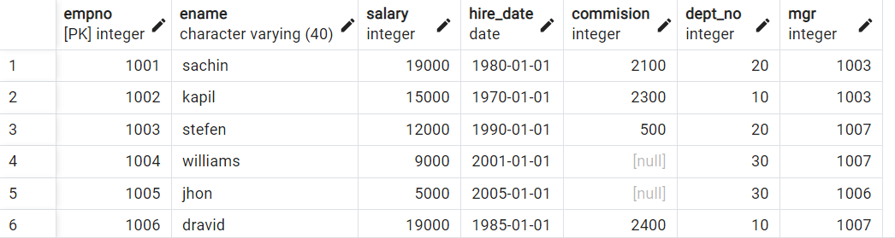

1. Write a SELECT statement to replace the char “a” with “#” in Employee Name ( Ex: **Sachin** as **S#chin)**

UPDATE employee

SET Ename = REPLACE(Ename, 'a', '#');

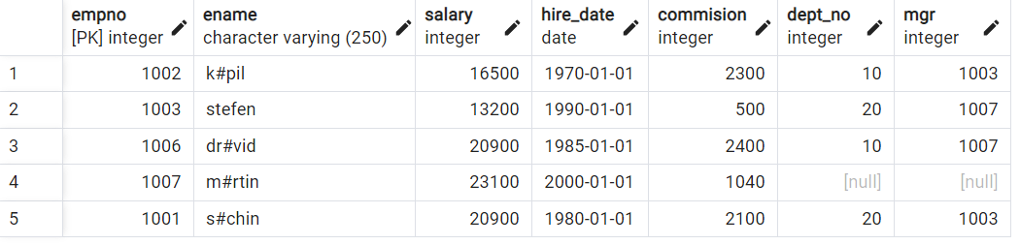

1. Write a query to fetch employee name and his/her manager name.

select E1.Ename as Manager, E2.Ename as Employee

from Employee E1 join Employee E2

on E1.EmpNo=E2.mgr;

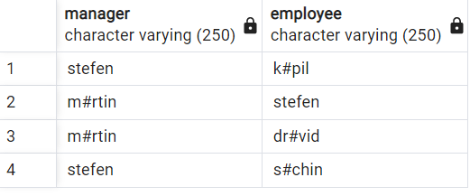

1. Fetch Dept NO , Total Salry of the Dept

select Dept_no,sum(Employee.salary)

from Employee

group by Dept_no;

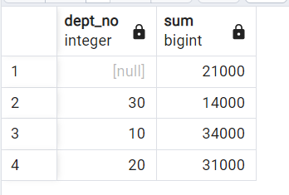

8)Write a query to fetch **ALL** the employee details along with department name, department location, irrespective of employee existance in the department.

select E.EmpNo,E.Ename,E.salary,E.hire_date,E.Commision,E.Dept_no,E,mgr,

D.Dept_no,D.Dname,D.Loc

From Employee E, Department D;

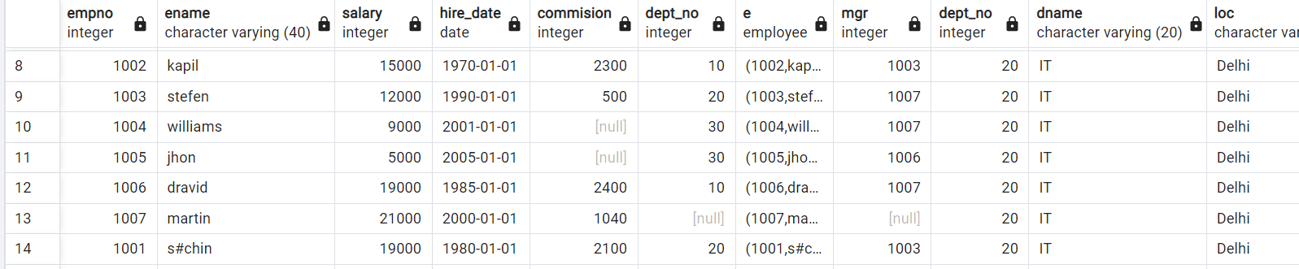

1. Write an update statement to increase the employee salary by 10 %

update employee

set salary = salary +(salary*10)/100;

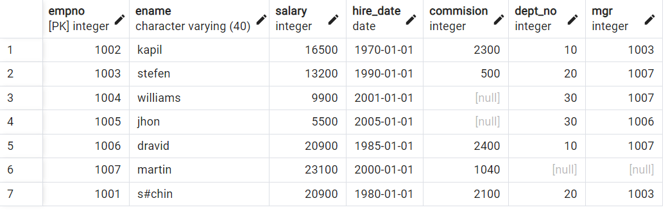

1. Write a statement to delete employees belong to Chennai location.

delete from employee

where dept_no in(select dept_no from department where Loc='Chennai');

select *from employee;

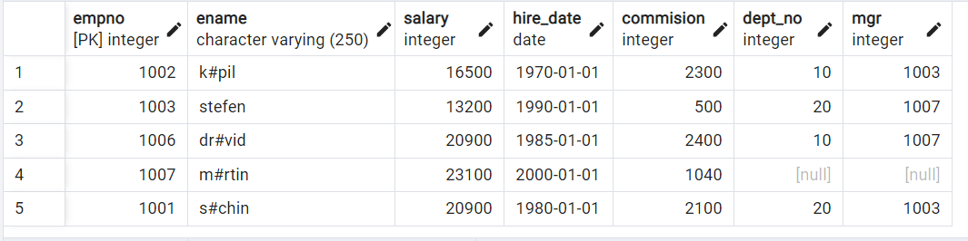

1. Get Employee Name and gross salary (sal + comission) .

select Ename,(salary+(salary*commision)/100) as totalSalary

from employee;

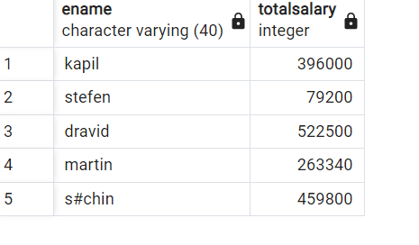

1. Increase the data length of the column Ename of Emp table from 100 to 250 using ALTER statement

alter table employee

alter column Ename type varchar(250);



1. Write query to get current datetime

select now();

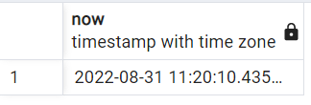

1. Write a statement to create STUDENT table, with related 5 columns

create table student(

Roll_no int2,

firstname varchar(20),

lastname varchar(20),

dob date,

adress varchar(100)

);



1. Write a query to fetch number of employees in who is getting salary more than 10000

select count(*)

from employee

where salary>10000;

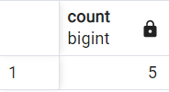

1. Write a query to fetch minimum salary, maximum salary and average salary from emp table.

select min(salary),max(salary),avg(salary)

from employee;

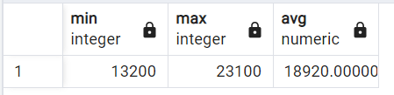

1. Write a query to fetch number of employees in each location

select department.Loc,count(*) as count

from employee

inner join department on employee.dept_no=department.dept_no

group by department.Loc;

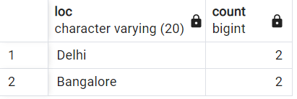

1. Write a query to display emplyee names in descending order

select Ename

from employee

order by Ename desc;

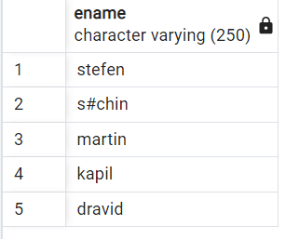

1. Write a statement to create a new table(**EMP_BKP**) from the existing **EMP** table

create table Emp_Bkp AS

select *from employee;

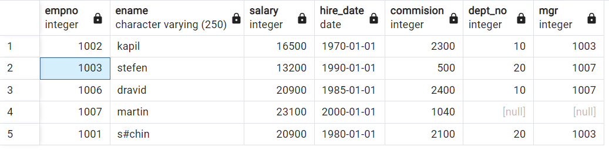

1. Write a query to fetch first 3 characters from employee name appended with salary.

select concat(substring(Ename,1,3),salary) as mixsalary

from employee;

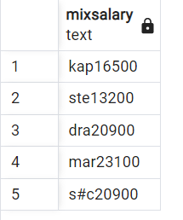

21) Get the details of the employees whose name starts with **S**

select *from Employee

where Ename like 's%';



1. **Get the details of the employees who works in Bangalore location**

SELECT Ename

FROM employee

WHERE dept_no

IN (SELECT dept_no FROM department WHERE department.Loc='Bangalore');

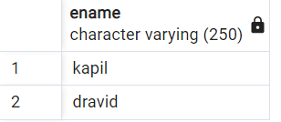

**23) Write the query to get the employee details whose name started within any letter between A and K**

select Ename

from employee

where Ename between 'a' and 'k';

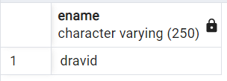

24) Write a query in SQL to display the employees whose manager name is **Stefen**

**select *from employee**

**where mgr in**

**(select EmpNo from employee where Ename='stefen');**

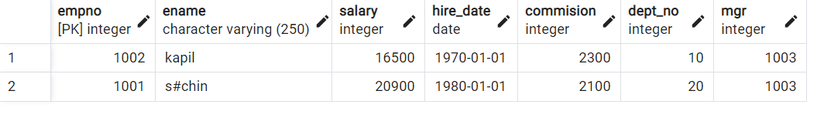

**25) Write a query in SQL to list the name of the managers who is having maximum number of employees working under him**

SELECT m.Ename,count(*)

FROM Employee w,Employee m

WHERE w.mgr = m.empNo

GROUP BY m.Ename

HAVING count(*) =

(SELECT MAX (mycount)

FROM

(SELECT COUNT(*) mycount

FROM Employee

GROUP BY mgr) a);

